# Questions for Chapter 5 – Instructor version

## 5.1 Union Jack

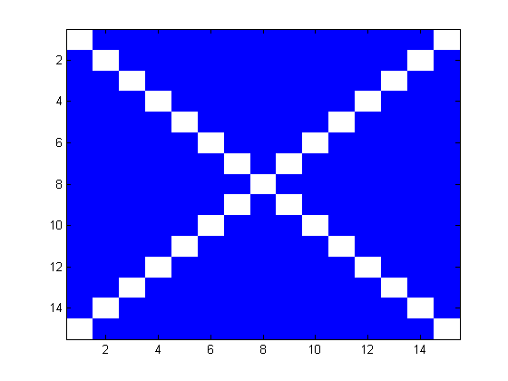Fill in the missing bits of code to make the series of figures

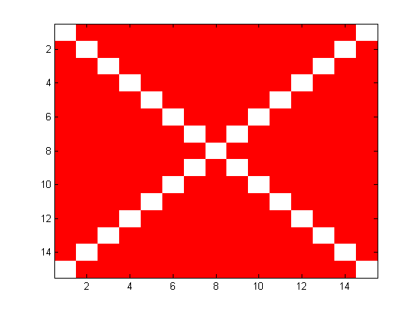clear all  
flagsize=15;  
saltire=zeros(flagsize);  
  
for i=1:flagsize  
 saltire(i, i)=1;  
 saltire((flagsize+1)-i, i)=1;  
end  
  
figure(1)  
image(saltire+1)  
cmap=**[0 0 1; 1 1 1; 0 0 1; 1 1 1];**

colormap(cmap)

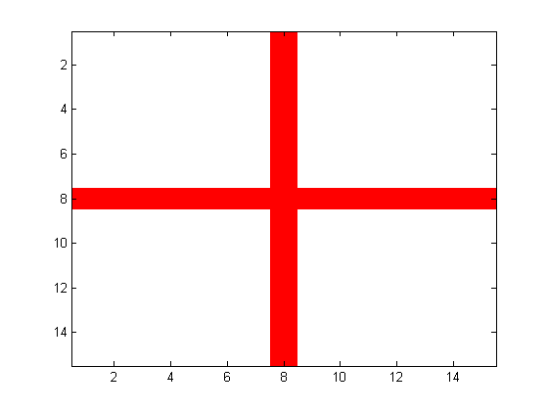  
  
figure(2)  
image(saltire+1)  
cmap= **[1 .1 .1; 1 1 1; 1 .1 .1; 1 1 1];**  
colormap(cmap)

george=zeros(flagsize);  
george(ceil(flagsize/2), :)=1;  
**george(:, ceil(flagsize/2))=1**

figure(3)  
image(george+1)  
cmap=[ 1 1 1 ; 1 0 0];

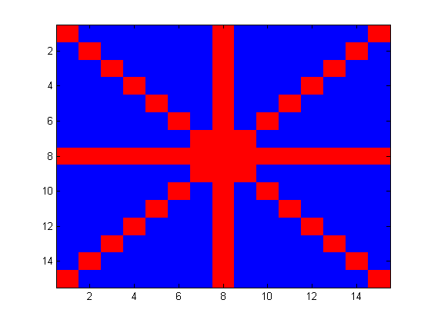colormap(cmap)

union=(saltire+(2*george))+1;  
union(union>3)=3;  
figure(4)  
image(union)

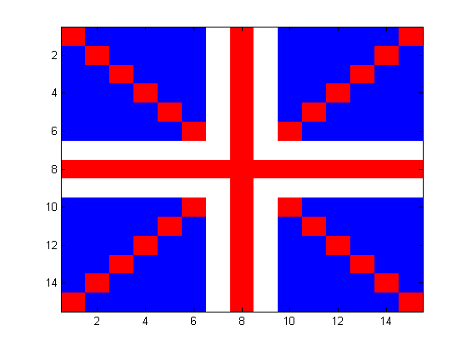cmap(1, :)= **[1 1 1];**  
cmap(2, :)= **[.1 1 .1];**

cmap(3, :)= **[1 .1 .1];**  
colormap(cmap)  
  
bars=[ceil(flagsize/2)-1 ceil(flagsize/2)+1];  
union(bars, :)=union(bars, :)+3;  
union(:,bars)=union(:, bars)+3;  
union(union>6)=union(union>6)-3;

% convert all values greater than 6 to 6  
figure(5)

image(union)

cmap(4, :)= **[1 1 1];**  
cmap(5, :)= **[.1 1 .1];**

cmap(6, :)= **[1 .1 .1];**  
colormap(cmap);

for i=1:flagsize

for j=1:flagsize

 if i==j-1 | j==i-1 …

|| i==j+1 || j==i+1

if union(i, j)<6

union(i, j)=5;

union(i, **j**)=5;

end

end

end

end

figure(6)  
image(union)  
colormap(cmap)  
axis off; axis equal

## 5.2 Indexing into a linear array in real world co-ordinates

Miguel collects data for an EEG experiment. Each session of data consists of 30 trials, each lasing 5s. The EEG machine records data every 2ms. Strangely his data looks like a perfect sinusoid, with 0 mean normally distributed noise.

ntrials=30;

durtrial=5*1000;

timevec=0:2:durtrial*ntrials;

data=sin((2*pi* timevec)/(durtrial))+.1*randn(size(timevec));

plot(timevec, data, '-')

a) What is the mean response during all the data points that are within the first ½ second of every trial

**mean(timevec(500))**

b) What is the mean response during the interval 2-2.5s of each trial?

**Mean(mean(timevec(2000:2500)))**

c) during which timepoints does the EEG response have values greater than 0.9?

**timepts2= find(data>=0.9)**

d) during which timepoints does the EEG response have values between 0.7 and 0.8?

**timepts3=data == 0.7:0.8**

(obviously you will get different answers each time because your data will vary each time).

## 5.3 Indexing into a matrix using real world co-ordinates

Sam Lin collects data on 70 rats. 20 of them were duds and their data were thrown away.

ratID=shuffle(1:70); ratID=sort(ratID(1:50));

On the remaining rats he collects 10000 trials, and he calculates the % correct across each bin of 100 trials.

ratID=shuffle(1:70); ratID=sort(ratID(1:50));

binsteps=1:100:10000;

[X, Y]=meshgrid(1:length(ratID), 1:length(binsteps));

per=Y+randi(10, size(Y))-5;

per(per>100)=100; per(per<0)=0;

a) image the rats performance in a matrix with trials along the x axis and rats along the y axis using a colormap that varies between white for 100% correct and black for 0% correct (not using imagesc)

**I can’t get this to work…I think it is because it keeps giving me an error for shuffle…????**

b) change the colormap so that values above 90% are white and values below 10% are black.

c) how many rats performed above 66% correct between trials 6001-7001?

d) which rats were they?

e) How many trials would be needed for 40/50 rats to be performing above 80%.

f) It turns out that for the rats with even ID numbers (2, 4, 6 10 etc.) the recording machine was on the blink for an interval between the 5678th trial and the 7533rd trial. Convert those numbers to NaN.